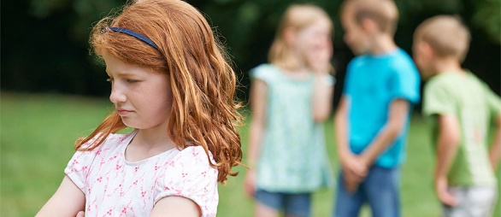

Rude, Mean, or Bullying?
A Child Therapist Defines the Differences

Signe Whitson, a child and adolescent therapist and author of 8 Keys to End Bullying and The 8 Keys to End Bullying Activity Book for Kids & Tweens, has a timely message for parents and educators: “there is a real need to draw a distinction between behavior that is rude, behavior that is mean and behavior that is characteristic of bullying.”

Whitson’s article was prompted by an encounter with a parent, who told her, “Last week, my daughter was bullied really badly after school!" and then went on to describe what Whitson characterized as a benign encounter between playful children throwing leaves.
Rude, she says, is “inadvertently saying or doing something that hurts someone else.” In children this takes the form of social errors like “burping in someone's face, jumping ahead in line, bragging about achieving the highest grade or even throwing a crushed up pile of leaves in someone's face.” The critical factor? “Incidents of rudeness are usually spontaneous, unplanned inconsideration, based on thoughtlessness, poor manners or narcissism, but not meant to actually hurt someone.”

Being mean involves “purposefully saying or doing something to hurt someone once (or maybe twice).” Unlike unthinking rudeness, “mean behavior very much aims to hurt or depreciate someone.... Very often, mean behavior in kids is motivated by angry feelings and/or the misguided goal of propping themselves up in comparison to the person they are putting down.” And while Whitson agrees that both rudeness and mean behavior require correction, they are “different from bullying in important ways that should be understood and differentiated when it comes to intervention.”
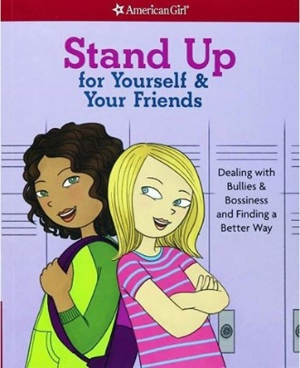
Bullying is “intentionally aggressive behavior, repeated over time that involves an imbalance of power.... Kids who bully say or do something intentionally hurtful to others and they keep doing it, with no sense of regret or remorse — even when targets of bullying show or express their hurt or tell the aggressors to stop.” Whitson gives examples of multiple kinds of bullying, including physical and verbal aggression, relational aggression (like social exclusion, hazing, or rumor spreading), and cyberbullying. The key aspect to all of them is the ongoing nature of the behavior, which leaves the victims feeling powerless and fearful.

